**Real Estate Sharks App Requirements Documentation**

Date: 2/8/2022

Version: 1.0.0

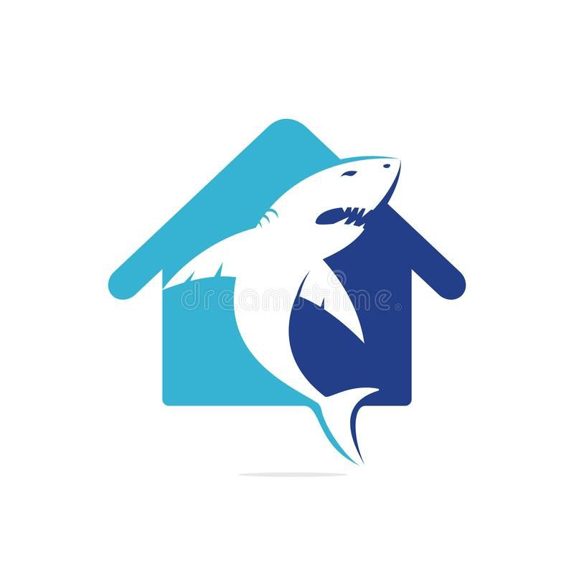

Source (<https://www.dreamstime.com/shark-house-vector-logo-design-home-icon-image158864365>)

Table of contents

1. Introduction
   1. Purpose
   2. Scope
   3. Conventions
   4. Client and Stakeholders
   5. Intended Audience
2. Overall Description
   1. Product description
   2. Product Perspective
   3. Constraints and Operating Environment
      1. Learning New Technologies
      2. Security
3. System Features
   1. Property DataBase
   2. Maintenance
   3. Explore
   4. Shared Documents
   5. Property Details
   6. User Account
   7. Help/Contact Info
4. Nonfunctional Requirements
   1. Reliability
   2. Usability
   3. Security
   4. Supportability

Document Revision History

|  |  |  |
| --- | --- | --- |
| Revision # | Date | Notes |
| v1.0.0 | 2/8/2022 | Initial document |

Team signatures: Cavan ODonnell, Gene Carlino

1. Introduction

* 1. Purpose
     1. This is the Requirements Specification document for a property management web application for Westcott Properties (WP). WP owns, manages and rents several properties using an outdated system involving a notebook and excel spreadsheets. This document describes the scope, objectives and goals of the web application being built for WP and 3rd party users.
  2. Scope
     1. The scope of this project is a web-based system that will support the management of all Westcott properties assets.   
          
        Excel spreadsheets and a notebook will be replaced by this new system. In addition to the new system, changes to Westcott Properties workflow will be implemented via the automation of some tasks. Increased data analytics will contribute to positive changes in Westcott Properties workflow.
  3. Conventions
     1. Put the formats used in this document, what are bold words for and what italic is used for and so on
     2. WP = Westcott Properties
     3. Client = Westcott Properties
  4. Client and Stakeholders
     1. Westcott Properties is the main client(Manager) of this application. Prospective third-party users will be future clients.
     2. The developers of this application will be making monetary investments to launch and upkeep this application. For this reason, Eugene Carlino and Cavan O Donnel are both stakeholders.
  5. Intended audience
     1. The intended audience for this document is the client and stakeholders.

1. Overall Description
   1. Product description
      1. This application will be a web-based property management for small family-owned companies. It will store documents for both the tenants and managers. It will provide the ability for tenants to request and schedule maintenance requests. It provide other information regarding the properties.
      2. It will provide data Analytics for the Manager (business owner) to allow for management feedback and profit loss overviews.
   2. Product perspective (PAGE 12 ON SRS IEE HANDOUT)
      1. Data input for this application will be independent of any other product. The output of all data and analytics will be done through the application and displayed on the application website.
      2. System interfaces (subsections as needed)
         1. Software Interface
            1. This application is a web app and will function on any web browser that supports Java.
         2. Front end software will be built on the React.js library/framework. This interface may have links to external websites and vice versa.
            1. Home Page/Login page
            2. Maintenance page
            3. Documents page
            4. Explore page
            5. Payments page
            6. Help page
            7. Property details page
         3. The backend will be integrated to the front end through DJango library, and run on a independent domain server.
   3. Constraints and Operating environment (page 15)
      1. Operating Environment
         1. This application will function within a web browser. We will assume the operating system being used is Windows or Mac OS. The user interface will be built with React JS. The backend will be built with Django.
      2. Constraints
         1. Learning New Technologies
            1. The Real Estate Sharks have little experience or are unfamiliar with some of the technologies that will be used to build this app.
         2. Security
            1. This application will contain private information that must be protected. Private information includes:
   4. User documentation requirements
   5. Assumptions and dependencies (page 15)

1. System Features
   1. Property Database (essential)
      1. Database with all relevant information needed for property management
      2. *Stimulus*
         1. *Fetch requests from the react.js front end will request information as need be as tenants are navigating the interface*
      3. *Response*
         1. *Post signals will be made by the DJango backup to fulfill “promises” requested by the front end as tenants are navigating the interface*
      4. *Functional requirements*
         1. *The database will need to functionally respond to requests from the front end and any other API request by third parties.*
   2. Maintenance (essential)
      1. Tenant can make a maintenance request, Manager can view request and respond to Tenant, the life cycle of each request will be viewable by both parties and updates can be made throughout the life cycle until the request is closed.
      2. Stimulus
         1. Tenant, once logged in and makes a Maintenace request
      3. Response
         1. Manager receives notification of maintenance request made by tenant. Manager will schedule maintenance and track the life cycle of request until closed.
      4. *Functional requirements*
         1. *Requests are tracked over there life-cycle*
   3. Explore (Secondary)
      1. Managers assets and open rentals will be dynamically monitored. Tenants will be able to explore other living options within the companies management range.
      2. Stimulus
         1. Tenant, once logged in will be able to go to the database on the website and view open rentals.
      3. Response
         1. They will have the option to apply for that rentals. External advertisements for open rentals will bring web searches to this page.
   4. Shared Documents
      1. All documents pertaining to the tenant and client relationship are stored and viewable by both parties.
         1. Examples of documents that would fit in this category:
            1. Contracts
            2. Utility Bills
            3. Rental Agreement
            4. insurance documents
      2. Stimulus
         1. Manager will send document(s) to Tenant.
      3. Response
         1. Tenant can view document(s). Documents will be stored in a database.
   5. Property Details ()
      1. Storage of all quantitative and qualitative data specific to each property/unit will be displayed in an easy-to-read format (table or list).
         1. Rental history
         2. Conditions
            1. Rooms
            2. Size
            3. Pre-existing damage
         3. Things to do/ amenities in proximity
         4. Tax information
         5. Maintenace records
      2. Stimulus
         1. Manager can upload information in a categorized manner.
         2. Manager can search and view property details.
      3. Response
         1. Information will be stored into data base.
   6. User Account ()
      1. Store information and allow the application to show the proper views based on account type.
      2. Stimulus
         1. Tenant logs into application.
      3. Response
         1. Application displays the appropriate view based on client permissions and settings.
   7. Help/Contact Info ()
      1. A banner on every page for each tenant. It will have information on safety and amenities specific to each unit.
      2. Stimulus
         1. Tennent clicks contact info
      3. Response
         1. The help/contact information for each unit will be displayed.

1. Nonfunctional Requirements
   1. Reliability
      1. The application will be fully functional if there is an internet connection
      2. The application domain host will be run on a server with surge protector and battery backup.
   2. Usability
      1. The Tenant will be able to use the application after one hour of training. The dashboard will be intuitive and straightforward. There will be a Help page that provides information on where to find things and what to click for what.
   3. Security
      1. The Tenant will log in to the application with a password protected account. Each Tenant will be assigned a user authentication certificate. Security questions for password reset will be provided.
   4. Supportability
      1. The dashboard and database will be able to accommodate new data categories without major re-engineering.
      2. The application will be viewable from all major web browsers. The application will have a registered domain name and be certified by an accredited certificate authority.

**Appendix A.1** UI/UX Questionnaire

Title: UI/UX Questionnaire

Purpose: The purpose of this questionnaire is to gather more information on the functional requirement and preferred UI/UX element look and feel. Please respond with a separate document or zip file containing the response information and digital elements.

Are there any specific Logos, pictures, videos, quotes, or other relevant advertising elements you would like incorporated or displayed in the app UI?

What specific colors and shapes would you like the app to display?

What is the desired navigation style of the app? We can do conventional banner/tab style; Modern "Flow" style website; or Icon style website navigation, like on iPhone or android.

List the functionality you would like the UI/UX to include.

List any data analytical functionality you would like the UI to include/display.

**Appendix A.2** Use Cases

(To come)

**Appendix A.3** Meeting Notes

Purpose for this meeting : Initial Meeting

Date/Time: 1/27/2022

Attendees: Cavan, Gene

Notes: Initial meeting. Filled out the project proposal doc.

Purpose for this meeting : finish filling out team assignment and assessment (initial)

Date/Time: 1/30/2022

Attendees: Cavan, Gene

Notes: Filled out the team assignments and initial assessment.

Purpose for this meeting : Finish proposal and team member assignments

Date/Time: 1/31/2022

Attendees: Cavan, Gene

Notes: Finalized the team member assignments, agreed on the django framework,

Purpose for this meeting : Talk about the Requirements Documentation due Tuesday

Date/Time: 2/2/2022

Attendees: Cavan, Gene

Notes: talked about how we would do the requirements documentation as a team, talked about react vs angular

Purpose for this meeting : Go over SRS draft

Date/Time: 2/6/2022 - 2pm

Attendees: Cavan, Gene

Notes: need to add diagrams to Appendices. Need to add functional requirements

Appendix B.1 UI/UX Interactive Overview Diagram

Appendix C: (prototype to come)

Sources:

<https://krazytech.com/projects/sample-software-requirements-specificationsrs-report-airline-database>

<http://web.cse.ohio-state.edu/~bair.41/616/Project/Example_Document/Req_Doc_Example.html>

<https://capstone.cs.ucsb.edu/team_docs_13/SRS/SRS_FooTang_Clan.pdf>

<https://capstone.cs.ucsb.edu/team_docs_13/SRS/SRS_PrograhamCracker.pdf>

<https://www.coursehero.com/file/53977714/SRS-Sample-1doc/> (pay-walled)

<https://t4tutorials.com/real-estate-management-system-project-functional-requirements/>

Talk about when done, handing over controll, if further assistance contact X Y Z

* Revisit explore and need consistency - reformat
* Requirements can have sub requirements